Chief Executive Officer
Richard Evans OBE
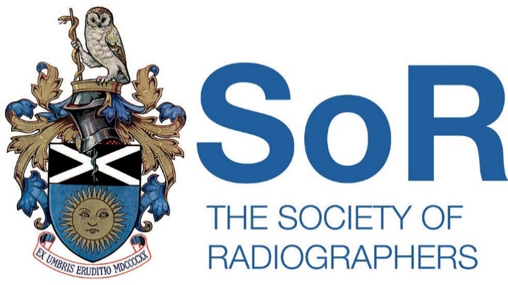

January 2021

Society of Radiographers Professional Indemnity Insurance Renewal

The Society of Radiographers (SoR) Professional Indemnity Insurance (PII) scheme is offered to all our SVT full members who practice vascular ultrasound. Whether you work in a large hospital, in the private sector, or as an individual, it is recommended that all SVT members take out personal PII cover.

If you work in the private sector it is important to ensure you are clear as to whether you are working as an employee or a subcontractor. A subcontractor would not be covered by the employer professional indemnity insurance and would need to ensure they take out PII. The SoR PII scheme covers an individual for professional indemnity, however if you work as a sole trader or have your own business you will also normally need other insurance policies for your business.

It is important to note the exclusions on SoR PII. It excludes any type of ultrasound scan performed for non-clinical reasons, for example the 4D scans offered to pregnant women or any other ‘lifestyle screening’. Clinical screening such as the NAAASP is covered and the SoR PII scheme is available to SVT NAAASP members to. Another important PII exclusion is that it does not cover scans that don’t have an appropriate clinical referral, so this will exclude anyone wishing to offer their own scans directly to the public.

To ensure you are covered you need to work within the scope of practice for vascular ultrasound, as defined by the CoR scheme. There is a special PII scheme for students, so trainees such as those on the MSC courses and other training pathways need to ensure they choose this category of insurance on the application form to provide cover for vascular ultrasound. The cover relates to clinical work and must be supervised work in accordance with the scope of practice for trainees. The level of autonomy will be in relation to the level of experience and training level achieved.

The cost of PII is £85.00 per annum. (This is a much reduced figure only available to our full SVT members (including AVS) in comparison to the full SoR membership fee of £285). You do not however get any other membership benefits of the SoR, such as the Synergy journal, website access, or IR representation.

To apply for PII, please complete the application form and return along with a cheque for £85.00 (made payable to The Society of Radiographers) to the Membership Department at the address below. To make a debit/credit card payment, please contact the Member Department on 020 7740 7200 option 1.

Kind Regards,

J. Wilkins

Joel Wilkins
Membership Services Manager

